**Practice Questions**

1. Litmus is a very common acid-base indicator which is extracted from lichens. It turns red in solutions that have a pH below 7 and blue when the pH is above 7. The substance responsible for the colour of litmus indicator is called 7-hydroxyphenoxazone. The structure of this molecule is shown below in its ‘red form’.



A simplified way to express this molecule is H*Lit*. This simplified notation is used in the equation below to demonstrate the reaction that litmus undergoes to change colour.

H*Lit*(aq) + H2O(l) ⇌ *Lit­ –*(aq) + H3O+(aq)

*red blue*

(a) Explain how litmus indicator works. Include details of the colour change observed in acidic and basic solution. (3 marks)

________________________________________________________________________

________________________________________________________________________

________________________________________________________________________

________________________________________________________________________

________________________________________________________________________

________________________________________________________________________

________________________________________________________________________

________________________________________________________________________

(b) Draw the ‘blue form’ of 7-hydroxyphenoxazone. (1 mark)

2. Oxalic acid (H2C2O4) is an organic acid, found in high levels in foods such as almonds, banana, rhubarb and spinach. It is a weak, diprotic acid which has many uses in the laboratory, such as in volumetric analysis where it can be used as a primary standard.

(a) Explain what is meant when oxalic acid is referred to as a ‘weak, diprotic acid’. Use relevant chemical equations to support your answer. (4 marks)

________________________________________________________________________

________________________________________________________________________

________________________________________________________________________

________________________________________________________________________

________________________________________________________________________

Some oxalic acid dihydrate crystals were used to produce a primary standard for use in a titration. 4.434 g of H2C2O4.2H2O(s) was dissolved in water and made up to 250.0 mL in a volumetric flask.

(b) Calculate the concentration of the oxalic acid primary standard. (2 marks)

The oxalic acid solution was then used to standardise some aqueous potassium hydroxide. A 20.00 mL sample of KOH(aq) required 17.85 mL of oxalic acid to reach equivalence. The relevant chemical equation for the titration is shown below.

2 KOH(aq) + H2C2O4(aq) → 2 H2O(l) + K2C2O4(aq)

(c) Calculate the concentration of KOH(aq). (3 marks)

3.

Phosphate buffered saline (PBS) is a solution which is commonly used in biological research. It was specifically designed so that the ion concentrations of the buffer solution match those found in the human body. The table below gives a standard ‘recipe’ for making PBS. The four salts are dissolved in water to produce the concentrations indicated.

|  |  |  |
| --- | --- | --- |
|  | **Final concentration when dissolved in distilled water** | |
| **Salt** | **Conc. (g L-1)** | **Conc. (mmol L-1)** |
| NaCl | 8.0 | 137 |
| KCl | 0.2 | 2.7 |
| Na2HPO4 | 1.42 | 10 |
| KH2PO4 | 0.24 | 1.8 |

(a) Which components would produce the buffering effect observed in PBS? Explain your answer. (2 marks)

________________________________________________________________________

________________________________________________________________________

________________________________________________________________________

(b) Write an equation showing the buffering system that would form. (1 mark)

________________________________________________________________________

(c) Explain how this buffer is able to resist a change in pH when a small amount of NaOH(aq) is added. (2 marks)

________________________________________________________________________

________________________________________________________________________

________________________________________________________________________

PBS is specially designed for use in molecular biology and microbiology labs, so it is made to particular specifications.

(d) Define ‘buffering capacity’ and describe how you could increase the buffering capacity of PBS if you did not have to take into account its biological uses. (3 marks)

________________________________________________________________________

________________________________________________________________________

________________________________________________________________________

________________________________________________________________________

4. Ba(OH)2(aq) + 2 HCl(aq) → BaCl2(aq) + 2 H2O(l)

Using the equation above, explain how it relates to the definition of an acid and a base as proposed by Arrhenius, and why it is that these two substances are able to neutralise each other. (3 marks)

________________________________________________________________________

________________________________________________________________________

________________________________________________________________________

________________________________________________________________________

________________________________________________________________________

________________________________________________________________________

Hydrocyanic acid, HCN(aq), is an extremely poisonous acid with a Ka value of 6.17 x 10-10. It is made by dissolving liquid or gaseous hydrogen cyanide in water. Small amounts of hydrogen cyanide can be extracted from the stones of some fruits such as cherries, apricots and apples, however it is generally manufactured on an industrial scale.

(d) Write two (2) equations for the ionisation of HCN in water, one illustrating the Arrhenius theory and one the Bronsted-Lowry theory. (2 marks)

|  |  |
| --- | --- |
| Arrhenius |  |
| Bronsted-Lowry |  |

(e) On the Bronsted-Lowry equation above, label the conjugate acid-base pairs. (2 marks)

(f) What information does the value of Ka give us about hydrocyanic acid, HCN(aq)? Explain your answer. (2 marks)

________________________________________________________________________

________________________________________________________________________

________________________________________________________________________

________________________________________________________________________

The Bronsted-Lowry theory accounts for the acidic and basic properties of a much wider array of substances whose properties cannot be explained by earlier theories.

(g) Complete the following table by stating the pH and giving a supporting equation for each of the substances. (3 marks)

|  |  |  |
| --- | --- | --- |
| **Substance** | **pH (acidic, basic or neutral)** | **Equation** |
| MgS(aq) |  |  |
| NH3(aq) |  |  |
| KHSO4(aq) |  |  |

Calculations

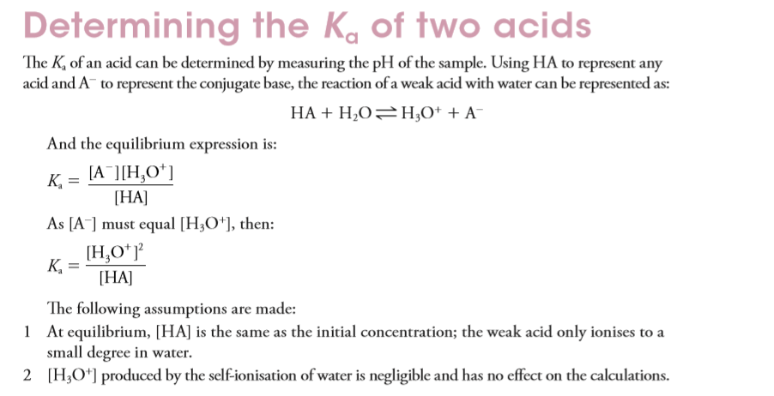

1.



2.

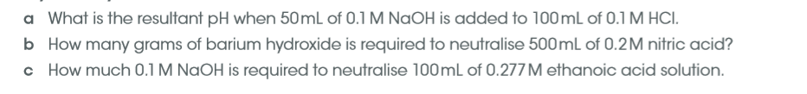

Answers

1.Litmus is a very common acid-base indicator which is extracted from lichens. It turns red in solutions that have a pH below 7 and blue when the pH is above 7. The substance responsible for the colour of litmus indicator is called 7-hydroxyphenoxazone. The structure of this molecule is shown below in its ‘red form’.



A simplified way to express this molecule is H*Lit*. This simplified notation is used in the equation below to demonstrate the reaction that litmus undergoes to change colour.

H*Lit*(aq) + H2O(l) ⇌ *Lit­ –*(aq) + H3O+(aq)

*red blue*

(a) Explain how litmus indicator works. Include details of the colour change observed in acidic and basic solution. (3 marks)

* **litmus works because the acidic / protonated form is a different colour (red) than the basic / deprotonated form (blue)**
* **In acidic solution the reverse reaction is favoured due to presence of protons/hydrogen ions/hydronium ions and protonated ie. red form of litmus dominates**
* **In basic solution the equilibrium shifts to the right due to the presence of hydroxide ions and the blue form dominates**

(b) Draw the ‘blue form’ of 7-hydroxyphenoxazone. (1 mark)



2. Oxalic acid (H2C2O4) is an organic acid, found in high levels in foods such as almonds, banana, rhubarb and spinach. It is a weak, diprotic acid which has many uses in the laboratory, such as in volumetric analysis where it can be used as a primary standard.

(a) Explain what is meant when oxalic acid is referred to as a ‘weak, diprotic acid’. Use relevant chemical equations to support your answer. (4 marks)

* **‘weak’ indicates ionisation of oxalic acid does not go to completion**
* **‘diprotic’ indicates each molecule of oxalic acid contains 2 ionisable/acidic hydrogen atoms**
* **H2C2O4 + H2O ⇌ HC2O4- + H3O+ OR H2C2O4 ⇌ HC2O4- + H+**
* **HC2O4- + H2O ⇌ C2O42- + H3O+ OR HC2O4- ⇌ C2O42- + H+**

Some oxalic acid dihydrate crystals were used to produce a primary standard for use in a titration. 4.434 g of H2C2O4.2H2O(s) was dissolved in water and made up to 250.0 mL in a volumetric flask.

(b) Calculate the concentration of the oxalic acid primary standard. (2 marks)

**n(H2C2O4.2H2O) = m/M**

**= 4.434 / 126.068**

**= 0.0351715 mol**

**c(H2C2O4) = n/V**

**= 0.0351715 / 0.2500**

**= 0.140686 mol L-1**

**= 0.1407 mol L-1 (4SF)**

The oxalic acid solution was then used to standardise some aqueous potassium hydroxide. A 20.00 mL sample of KOH(aq) required 17.85 mL of oxalic acid to reach equivalence. The relevant chemical equation for the titration is shown below.

2 KOH(aq) + H2C2O4(aq) → 2 H2O(l) + K2C2O4(aq)

(c) Calculate the concentration of KOH(aq). (3 marks)

**n(H2C2O4) = cV**

**= 0.140686 x 0.01785**

**= 0.0025112 mol**

**n(KOH) = 2 x n(H2C2O4)**

**= 0.0050225 mol**

**c(KOH) = n/V**

**= 0.0050225 / 0.02000**

**= 0.251124 mol L-1**

**= 0.2511 mol L-1 (4SF)**

**3.**

Phosphate buffered saline (PBS) is a solution which is commonly used in biological research. It was specifically designed so that the ion concentrations of the buffer solution match those found in the human body. The table below gives a standard ‘recipe’ for making PBS. The four salts are dissolved in water to produce the concentrations indicated.

|  |  |  |
| --- | --- | --- |
|  | **Final concentration when dissolved in distilled water** | |
| **Salt** | **Conc. (g L-1)** | **Conc. (mmol L-1)** |
| NaCl | 8.0 | 137 |
| KCl | 0.2 | 2.7 |
| Na2HPO4 | 1.42 | 10 |
| KH2PO4 | 0.24 | 1.8 |

(a) Which components would produce the buffering effect observed in PBS? Explain your answer. (2 marks)

* **Na2HPO4 and KH2PO4**
* **The HPO42- / H2PO4- are a weak conjugate acid-base pair**

(b) Write an equation showing the buffering system that would form. (1 mark)

* **H2PO4- + H2O ⇌ HPO42- + H3O+ (B1)**

**OR**

* **H2PO4- + OH- ⇌ HPO42- + H2O (B2)**

(c) Explain how this buffer is able to resist a change in pH when a small amount of NaOH(aq) is added. (2 marks)

* **The addition of NaOH neutralises the H3O+ (B1) / increases the concentration of OH- (B2)**
* **The system then favours the forward reaction to produce more H3O+ (B1) / reduce the amount of OH- (B2), thereby maintaining a constant pH**

PBS is specially designed for use in molecular biology and microbiology labs, so it is made to particular specifications.

(d) Define ‘buffering capacity’ and describe how you could increase the buffering capacity of PBS if you did not have to take into account its biological uses. (3 marks)

* **buffering capacity is the extent to which a buffer can maintain a constant pH when additional H3O+ or OH- is being added**
* **the buffering capacity of PBS could be increased by combining the HPO42- / H2PO4- in equimolar amounts, and**
* **by increasing the concentration of both HPO42- / H2PO4-**

**4.**

Using the same equation, explain how it relates to the definition of an acid and a base as

proposed by Arrhenius, and why it is that these two substances are able to neutralise each

other. (3 marks)

* **according to Arrhenius; acids are substances that contain H in their formula and produce H+ ions in solution (i.e. HCl fits definition)**
* **bases are substances that have OH in their formula and produce OH- ions in solution (i.e. Ba(OH)2 fits definition)**
* **they are able to neutralise each other because H+ + OH- → H2O**

Hydrocyanic acid, HCN(aq), is an extremely poisonous acid with a Ka value of 6.17 x 10-10. It is made by dissolving liquid or gaseous hydrogen cyanide in water. Small amounts of hydrogen cyanide can be extracted from the stones of some fruits such as cherries, apricots and apples, however it is generally manufactured on an industrial scale.

(d) Write two (2) equations for the ionisation of HCN in water, one illustrating the Arrhenius theory and one the Bronsted-Lowry theory. (2 marks)

|  |  |
| --- | --- |
| Arrhenius | **HCN(aq) ⇌ H+(aq) + CN-(aq)** |
| Bronsted-Lowry | **HCN(aq) + H2O(l) ⇌ H3O+(aq) + CN-(aq)**  **A B CA CB** |

(e) On the Bronsted-Lowry equation above, label the conjugate acid-base pairs. (2 marks)

(f) What information does the value of Ka give us about hydrocyanic acid, HCN(aq)? Explain your answer. (2 marks)

* **tells us that HCN is a weak acid i.e. ionisation of HCN does not occur to a large extent**
* **since K is equivalent to P/R, very low K value indicates that there is a much higher concentration of reactants present at equilibrium i.e. unionised HCN**

